05/07/24

1. **Package:**

The package keyword creates a package.

A package in Java is used to group related classes. Think of it as **a folder in a file directory**.

We use packages to avoid name conflicts and to write better maintainable code.

Packages can be considered as data encapsulation

Package names and directory structure are closely related

Packages are divided into two categories:

* Built-in Packages (packages from the Java API)

for example, **swing, util, net, io, AWT, lang, javax**, etc.

* User-defined Packages (create your own packages)

**Advantages:**

* Java package provides access protection.
* Java package removes naming collision.

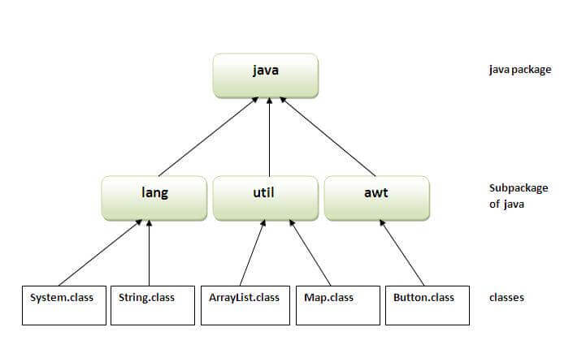

If you are not using any IDE, you need to follow the **syntax** given below:

**javac -d directory javafilename**

**Example:**

Package **com.neoteric.java0407;**

It is a java declaration. It specifies that the classes and interfaces defined in this file are part of the ‘com.neoteric.java0407’ package.

1. **Import:**

The import keyword is used to import a package, class, or interface.

It allowing you to use them in your code without having to use their fully qualified names.

This helps to make the code more readable and manageable.

**Example:**

import **org.junit.jupiter.api.Test**:

**org.junit.jupiter.api.Test**: This is the fully qualified name of the ‘Result’ class. It tells the Java compiler to include this class from the ’org.junit.jupiter.api.Test;’ package, which is part of the JUnit testing framework.

The **Test** is a method. When a method is annotated with @Test, JUnit will execute this method as part of the test run.

1. **Public:**

A Java public keyword is an access specifier.

It can be assigned to variables, methods, constructors, and classes.

It is the most non-restricted type of access specifier.

It is an access specifier that is accessible everywhere. So, we can easily access the public inside and outside the class and package.

If a class contains a public class, the name of the program must be similar to the public class name.

**Access Specifiers:**

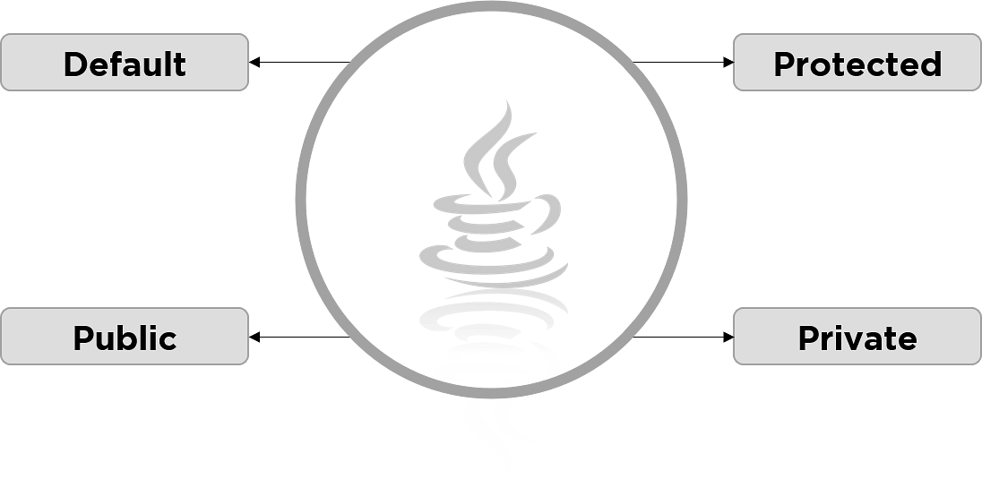

1. **Class:**

A class keyword is the most common keyword that is used to declare a new Java class.

A class is a template or blueprint from which objects are created. It is a logical entity. It can't be physical.

A class is a container that contains the block of code that includes field, method, constructor, etc.

* Every object is an instance of a class.
* A class name must be unique within a package.
* We can assign only public, abstract, strictfp and final modifier to class.
* We can assign other modifiers like private, protected, and static to the inner Java class.

1. **Char:**

The char is a keyword and it is a primitive data type.

It is used to declare the character-type variables and methods.

It is capable of holding the unsigned 16-bit Unicode characters.

* The char range lies between 0 to 65,535 (inclusive).
* Its default value is '\u0000'.
* Its default size is 2 bytes.
* It is used to store characters.

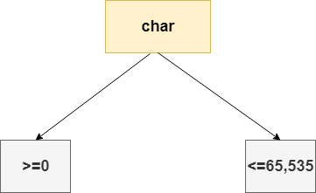

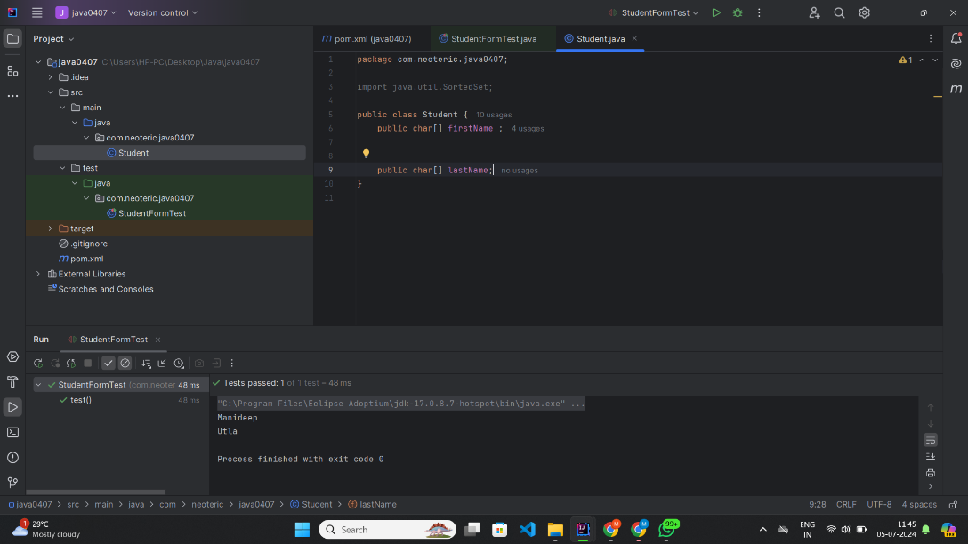

Fig: It shows the Student.java and it passes the test case.

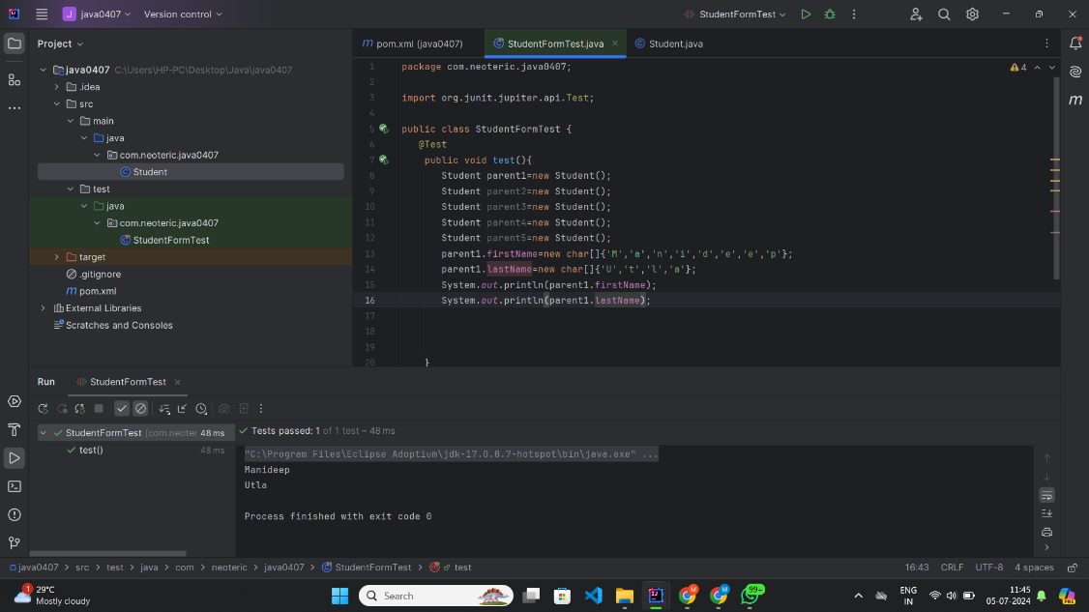

Fig: It shows the StudentFormTest.java and it passes the test case.